CHAPTER 16

Simulation

KEY CONCEPTS

ILLUSTRATED ANSWERED
CONCEPT PROBLEMS PROBLEMS

Simulation of:

One Event 1,2 9

Two Events 3 7,8,10,11,14

Multiple Events 4 13,15

Comparison of Expected
and Simulated Outcomes 1,6 9,10

Simulation of
Decision Alternatives 2 7,10,11,14

Simulation Applications:

Inventory Systems 2 10,11,13

Waiting Lines 3,4 8,12,15

Markov Processes 5 16

Project Times 6 9

Spreadsheet Example 1,5

REVIEW

1. Computer simulation is one of the most frequently employed management science techniques. It is typically used to model random processes that are too complex to be solved by analytical methods.

2. One begins a computer simulation by developing a mathematical statement of the problem. The model should be realistic yet solvable within the speed and storage constraints of the computer system being used. Input values for the model as well as probability estimates for the random variables must then be determined.

3. Random variable values are utilized in the model through a technique known as Monte Carlo simulation. Here each random variable is mapped to a set of numbers so that each time one number in that set is generated, the corresponding value of the random variable is given as an input to the model. The mapping is done in such a way that the likelihood that a particular number is chosen is the same as the probability that the corresponding value of the random variable occurs.
4. Because a computer program generates random numbers for the mapping according to some formula, the numbers are not truly generated in a random fashion. However, using standard statistical tests, the numbers can be shown to appear to be drawn from a random process. Appendix E is a table of pseudo-random digits.

5. In a fixed-time simulation model, time periods are incremented by a fixed amount. For each time period a different set of data from the input sequence is used to calculate the effects on the model.

6. In a next-event simulation model, time periods are not fixed but are determined by the data values from the input sequence.

7. The computer program that performs the simulation is called a simulator. While this program can be written in any general purpose language (e.g. BASIC, FORTRAN, C++, etc.), special languages that reduce the amount of code which must be written to perform the simulation have been developed such as SIMSCRIPT, GPSS, SLAM, and Arena.

8. Validation/verification of both the model and the method used by the computer to carry out the calculations is extremely important. Models which do not accurately reflect real world behavior cannot be expected to generate meaningful results. Likewise, errors in programming can result in nonsensical results.

9. Validation/verification is generally done by having an expert review the model and the computer code for errors. If possible, the simulation should be run using actual past data. Predictions from the simulation model should be compared with historical results.

10. Experimental design is an important consideration in the simulation process. Issues such as the length of time of the simulation and the treatment of initial data outputs from the model must be addressed prior to collecting and analyzing output data.

11. Normally one is interested in results for the steady state (long run) operation of the system being modeled. Hence, the initial data inputs to the simulation generally represent a start-up period for the process and it may be important that the data outputs for this start-up period be ignored for predicting this long run behavior.

12. For each policy under consideration by the decision maker, the simulation is run by considering a long sequence of input data values (given by a pseudo-random number generator). Whenever possible, different policies should be compared by using the same sequence of input data.

13. Among the advantages of computer simulation is the ability to gain insights into the model solution which may be impossible to attain through other techniques. Also, once the simulation has been developed, it provides a convenient experimental laboratory to perform "what if" and sensitivity analysis.

14. Two major disadvantages of simulation are: (1) a large amount of time may be required to develop the simulation; and, (2) there is no guarantee that the solution obtained will actually be optimal. Simulation is, in effect, a trial-and-error method of comparing different policy inputs. It does not determine if some input which was not considered could have provided a better solution for the model.
FLOW CHART OF
COMPUTER SIMULATION PROCESS

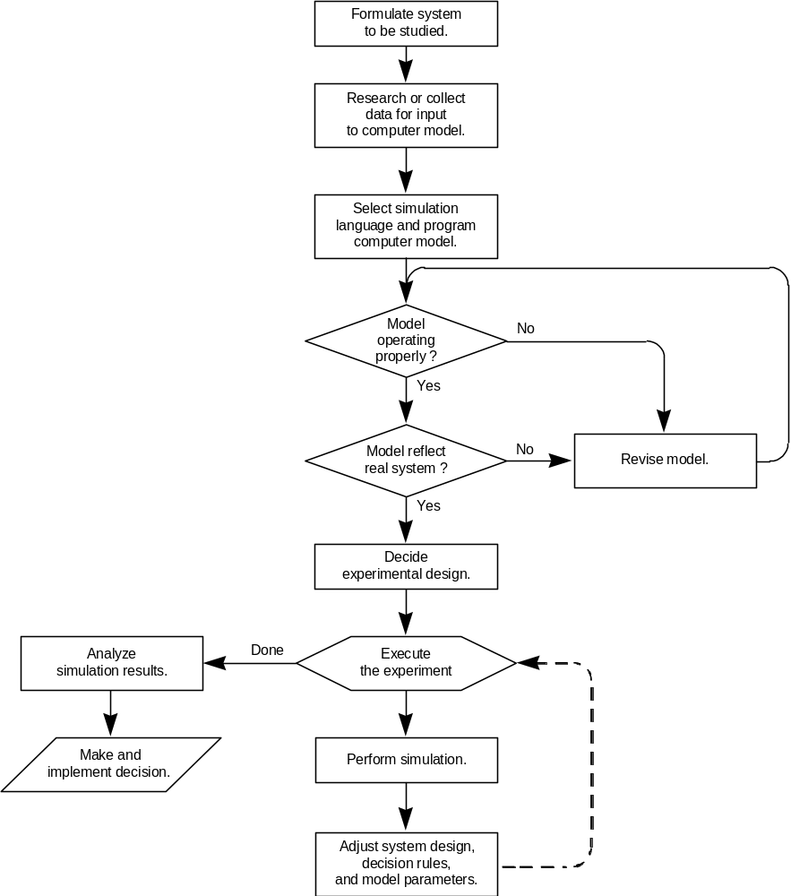

ILLUSTRATED PROBLEMS

NOTE: Several of the problems in this chapter relate to topics of other chapters such as inventory, waiting lines, markov processes, and projects. Where applicable, you are encouraged to compare your simulation results with those of analytic procedures covered in other chapters. However, you might find differences in the results that are due most likely to the small number of simulation trials performed.

PROBLEM 1

The price change of shares of Probablistics, Inc. has been observed over the past 50 trades. The frequency distribution is as follows:

Frequency
Price Change (Number of Trades)
-3/8 4
-1/4 2
-1/8 8
0 20
+1/8 10
+1/4 3
+3/8 2
+1/2 1
Total = 50

a) Develop a relative frequency distribution for this data.

b) If the current price per share of Probablistics is 23, use random numbers to simulate the price per share over the next 20 trades. (For random numbers, use the first two numbers at the bottom of column 1 of Appendix E and move up.)

- Compare the simulated price after 20 trades (from part b) with the expected price one would obtain based on the probability distribution.

d) Using a spreadsheet, simulate 10 trades.

SOLUTION 1

a) To develop a relative frequency distribution for this data, divide the frequency of each price by the total number of trades. The results are shown in the table below.

b) To develop a simulation for the future prices, assign a random number to each price change so that the probability of seeing a certain price corresponds to its probability (relative frequency).

One such assignment of numbers is:

Price Change Relative Frequency Random Numbers
-3/8 .08 00 - 07
-1/4 .04 08 - 11
-1/8 .16 12 - 27
0 .40 28 - 67
+1/8 .20 68 - 87
+1/4 .06 88 - 93
+3/8 .04 94 - 97
+1/2 .02 98 - 99

According to the instructions, the first random number will be 62, the second 32, etc. The simulated results are:

Trade Number Rand. Number Price Change Stock Price
1 62 0 23
2 32 0 23
3 71 +1/8 23 1/8
4 94 +3/8 23 1/2
5 04 -3/8 23 1/8
6 97 +3/8 23 1/2
7 58 0 23 1/2
8 67 0 23 1/2
9 78 +1/8 23 5/8
10 14 -1/8 23 1/2
11 54 0 23 1/2
12 48 0 23 1/2
13 84 +1/8 23 5/8
14 66 0 23 5/8
15 73 +1/8 23 3/4
16 13 -1/8 23 5/8
17 91 +1/4 23 7/8
18 10 -1/4 23 5/8
19 62 0 23 5/8
20 32 0 23 5/8

c) Based on the probability distribution, the expected price change per trade can be calculated by: (.08)(-3/8) + (.04)(-1/4) + (.16)(-1/8) + (.40)(0) + (.20)(1/8) + (.06)(1/4) + (.04)(3/8) + (.02)(1/2) = .005

The expected price change for 20 trades is (20)(.005) = .10. Hence, the expected stock price after 20 trades is 23 + .10 = 23.10. This is lower than the simulated price of 23.625 (or 23 5/8).

d) Spreadsheet for the stock price simulation
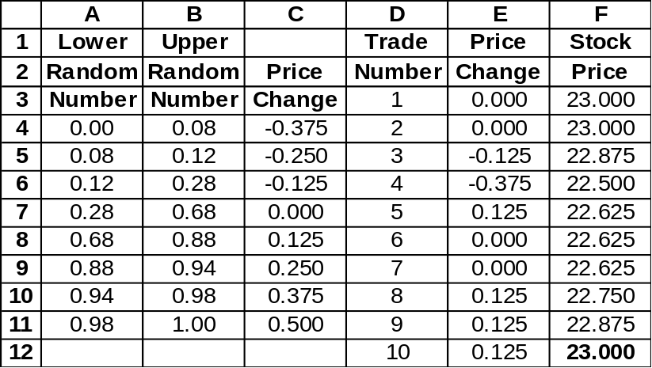
=VLOOKUP(RAND(),$A$4:$C$11,3)

PROBLEM 2

Shelly's Supermarket has just installed a postage stamp vending machine. Based on one month of operation, Shelly's estimates the number of postage stamps sold per day can be approximated by the following distribution:

Number Sold Per Day Probability
20 .10
30 .15
40 .20
50 .25
60 .20
70 .10

Shelly's makes a $.02 profit per postage stamp. The vending machine holds 230 stamps and it costs Shelly's $2.00 in labor to fill the machine.

a) Determine the mean number of stamps sold per day.

b) Determine the mean time until the machine is empty.

c) Assume that Shelly's adopts the following policy. Shelly's will fill the machine at the beginning of every n-th day, where n is the answer found in part (b). Conduct a 20-day simulation and determine the expected profit per day. Assume the machine must be filled on the first day. (Use the first two numbers of column 3 of Appendix E, beginning at the top for the random numbers.)

d) Suppose Shelly's fills the machine every (n-1)-th day. Repeat the 20-day simulation and compare the answer with that of part (c). Which policy would you recommend?
SOLUTION 2

The flow chart below can assist in setting up the simulations.

a) The mean number of stamps sold daily =
(.10)(20)+(.15)(30)+(.20)(40)+(.25)(50)+(.20)(60)+(.10)(70) = 46.

b) The mean time until the machine is empty is:
(Machine capacity)/(Mean number of stamps sold per day) = 230/46 = 5 days.

Flow Chart of Vending Machine Simulation

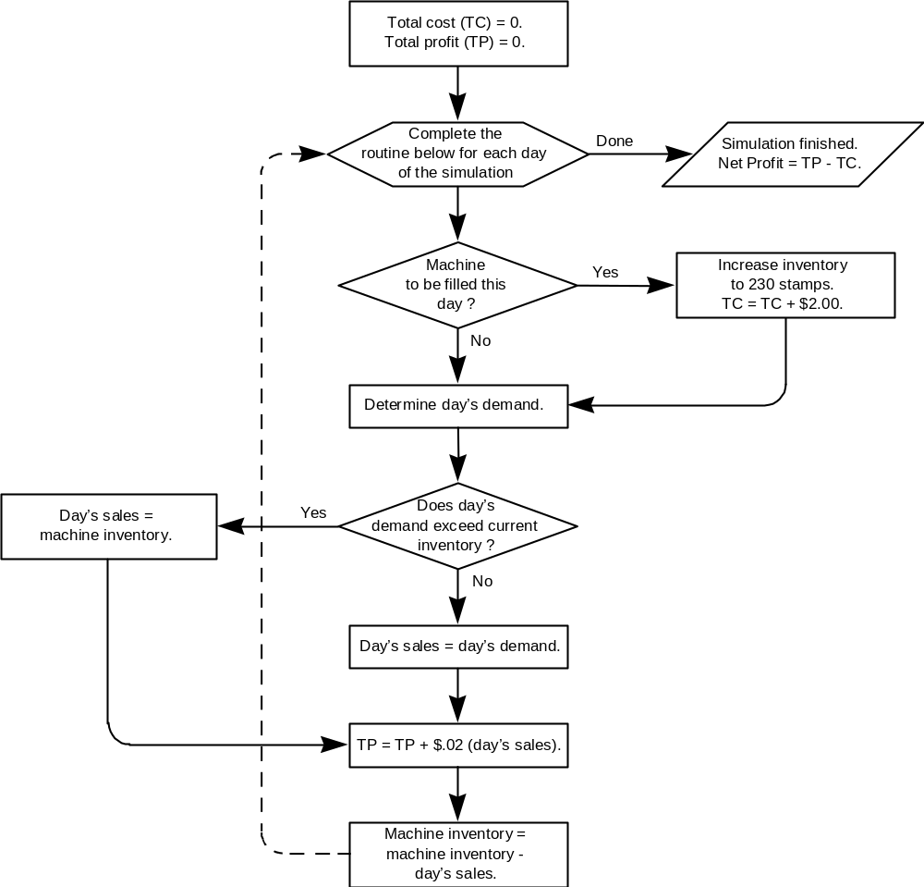
13 03 20 120 .40 -- .40
Assuming Shelly's fills the machine every fifth day, determine a set of random numbers corresponding to each sales level.

Number Sold Per Day Range Of Numbers
20 00 - 09
30 10 - 24
40 25 - 44
50 45 - 69
60 70 - 89
70 90 - 99

Following the instructions of using the first two numbers in column 3 of Appendix E generates the following simulation:

Number Profit
Of Stamps From Cost Of
Random Left In Sale Of Refilling Daily
Day Number Demand Machine Stamps Machine Profit
1 71 60 170 1.20 2.00 - .80
2 95 70 100 1.40 -- 1.40
3 83 60 40 1.20 -- 1.20
4 44 40 0 .80 -- .80
5 34 40 0 0* -- 0
6 49 50 180 1.00 2.00 -1.00
7 88 60 120 1.20 -- 1.20
8 56 50 70 1.00 -- 1.00
9 05 20 50 .40 -- .40
10 39 40 10 .80 -- .80
11 75 60 170 1.20 2.00 - .80
12 12 30 140 .60 -- .60
14 59 50 70 1.00 -- 1.00
15 29 40 30 .80 -- .80
16 77 60 170 1.20 2.00 - .80
17 76 60 110 1.20 -- 1.20
18 57 50 60 1.00 -- 1.00
19 15 30 30 .60 -- .60
20 53 50 0 .60** -- .60
Total Profit = $9.60

* 0 since the machine was empty
** .60 since there were only 30 stamps left in the machine

Expected Profit per Day = (9.60)/20 = $.48.

d) In order to compare the two policies, the same set of input data should be generated. Thus the simulation below has the same input for daily demand as that of part (c). In this part, the machine is to be filled every fourth day.

Number Profit
Of Stamps From Cost Of
Random Left In Sale Of Refilling Daily
Day Number Demand Machine Stamps Machine Profit
1 71 60 170 1.20 2.00 - .80
2 95 70 100 1.40 -- 1.40
3 83 60 40 1.20 -- 1.20
4 44 40 0 .80 -- .80
5 34 40 190 0 2.00 -1.20
6 49 50 140 1.00 -- 1.00
7 88 60 80 1.20 -- 1.20
8 56 50 30 1.00 -- 1.00
9 05 20 210 .40 2.00 -1.60
10 39 40 170 .80 -- .80
11 75 60 110 1.20 -- 1.20
12 12 30 80 .60 -- .60
13 03 20 210 .40 2.00 -1.60
14 59 50 160 1.00 -- 1.00
15 29 40 120 .80 -- .80
16 77 60 60 1.20 -- 1.20
17 76 60 170 1.20 2.00 - .80
18 57 50 120 1.00 -- 1.00
19 15 30 90 .60 -- .60
20 53 50 40 .60 -- 1.00
Total Profit = $8.80

Expected Daily Profit = $ .44

Based on the results of this simulation, Shelly's should fill the machine every fifth day rather than every fourth day.

PROBLEM 3

Wayne International Airport primarily serves domestic air traffic. Occasionally, however, a chartered plane from abroad will arrive with passengers bound for Wayne's two great amusement parks, Algorithmland and Giffith's Cherry Preserve.
Whenever an international plane arrives at the airport the two customs inspectors on duty set up operations to process the passengers.
Incoming passengers must first have their passports and visas checked. This is handled by one inspector. The time required to check a passenger's passports and visas can be described by the following probability distribution:

Time Required to
Check a Passenger's
Passport and Visa Probability
20 seconds .20
40 seconds .40
60 seconds .30
80 seconds .10

After having their passports and visas checked, the passengers next proceed to the second customs official who does baggage inspections. Passengers form a single waiting line with the official inspecting baggage on a first come, first served basis.
The time required for baggage inspection has the following probability distribution:

Time Required For
Baggage Inspection Probability
No Time .25
1 minute .60
2 minutes .10
3 minutes .05

a) If a chartered plane from abroad lands at Wayne Airport with 80 passengers, use simulation to determine how long it will take for the first 20 passengers to clear customs. (From Appendix E, use the first two digits in column 8 for passport control and the first two digits in column 9 for baggage inspection.)

b) What is the average length of time a customer waits before having his bags inspected after he clears passport control? How is this estimate biased?

NOTE: The value of a decision variable is an input to a simulation model, whereas it is an output to an optimization model (like a linear programming model). A simulation model does not decide the value of a decision variable, it evaluates the result, in terms of some objective, of a given value of a decision variable.
SOLUTION 3

The problem is easiest to set up as a next-event simulation model. The random number mappings are:
Time Required to
Check a Passenger's Random
Passport and Visa Probability Numbers
20 seconds .20 00 - 19
40 seconds .40 20 - 59
60 seconds .30 60 - 89
80 seconds .10 90 - 99

Time Required For Random
Baggage Inspection Probability Numbers
No Time .25 00 - 24
1 minute .60 25 - 84
2 minutes .10 85 - 94
3 minutes .05 95 - 99

For each passenger the following information must be recorded:
(1) When his service begins at the passport control inspection
(2) The length of time of this service
(3) When his service begins at the baggage inspection
(4) The length of time of this service

Note the following relationships:
(1) Time a passenger begins service by the passport inspector =
(Time the previous passenger started passport service)
+ (Time of previous passenger's passport service)

(2) Time a passenger begins being served by the baggage inspector depends on
whether or not the passenger must wait in line for this service.
If passenger does not wait in line for baggage inspection:
Time a passenger begins being served by the baggage inspector =
(Time passenger completes service with the passport control inspector)
If the passenger does wait in line for baggage inspection:
Time a passenger begins being served by the baggage inspector =
(Time previous passenger completes service with the baggage inspector)

(3) Time a customer completes service at the baggage inspector =
(Time customer begins service with baggage inspector) +
(Time required for baggage inspection).

The following table describes the simulation: (service times in minutes)

Pass- Passport Control Baggage Inspections
enger Time Random Service Time Time Random Service Time
Number Begin Number Time End Begin Number Time End
1 0:00 93 1:20 1:20 ⏐ 1:20 13 0:00 1:20
2 1:20 63 1:00 2:20 ⏐ 2:20 08 0:00 2:20
3 2:20 26 :40 3:00 ⏐ 3:00 60 1:00 4:00
4 3:00 16 :20 3:20 ⏐ 4:00 13 0:00 4:00
5 3:20 21 :40 4:00 ⏐ 4:00 68 1:00 5:00
6 4:00 26 :40 4:40 ⏐ 5:00 40 1:00 6:00
7 4:40 70 1:00 5:40 ⏐ 6:00 40 1:00 7:00
8 5:40 55 :40 6:20 ⏐ 7:00 27 1:00 8:00
9 6:20 72 1:00 7:20 ⏐ 8:00 23 0:00 8:00
10 7:20 89 1:00 8:20 ⏐ 8:20 64 1:00 9:20
11 8:20 49 :40 9:00 ⏐ 9:20 36 1:00 10:20
12 9:00 64 1:00 10:00 ⏐ 10:20 56 1:00 11:20
13 10:00 91 1:20 11:20 ⏐ 11:20 25 1:00 12:20
14 11:20 02 :20 11:40 ⏐ 12:20 88 2:00 14:20
15 11:40 52 :40 12:20 ⏐ 14:20 18 0:00 14:20
16 12:20 69 1:00 13:20 ⏐ 14:20 74 1:00 15:20
17 13:20 29 :40 14:00 ⏐ 15:20 75 1:00 16:20
18 14:00 96 1:20 15:20 ⏐ 16:20 29 1:00 17:20
19 15:20 95 1:20 16:40 ⏐ 17:20 80 1:00 18:20
20 16:40 84 1:00 17:40 ⏐ 18:20 25 1:00 19:20

For example, passenger 1 begins being served by the passport control inspector immediately. His service time is 1:20 (80 seconds) at which time he goes to the baggage inspector who waves him through without inspection.
Passenger 2 begins service with passport inspector 1:20 minutes (80 seconds) after arriving there (as this is when passenger 1 is finished) and requires 1:00 minute (60 seconds) for passport inspection. He is waved through baggage inspection as well. The process continues in this manner.

a) Passenger 20 clears customs after 19 minutes 20 seconds.

- For each passenger calculate his waiting time (in seconds):

(Baggage Inspection Begins) - (Passport Control Ends) =
0+0+0+40+0+20+20+40+40+0+20+20+0+40+120+60+80+60+40+40 = 640 seconds.

This gives an average of 640/20 = 32 seconds per passenger. This is a biased estimate
because we assume that the simulation began with the system empty, resulting in
underestimated average waiting time.

PROBLEM 4

Attendees at the National Management Science Society (NMSS) Conference register by first standing in line to pay their fees. They then proceed to a designated line based on the first letter of their last name to collect their conference materials.
At the conference, it is planned to have three different parallel lines for the collection of materials: one each for people whose last names begin with A-H, I-Q, and R-Z respectively.
During each minute of the morning registration period it is anticipated that attendees will arrive to pay their fees according to the following distribution:

Number of Arrivals Probability
0 .30
1 .30
2 .30
3 .10

The time to pay one's fees is either one minute or two minutes depending upon whether one uses a check or credit card. The probability of a one-minute time is .60.
After paying his fees, an attendee then goes to the correct line for the conference materials. At this year's conference 35% of the attendees have last names beginning with A-H, 36% with last names beginning with I-Q, and 29% with last names beginning with R-Z. The time required to pick up conference materials is fixed at 2 minutes.

a) Simulate the waiting line for the first 30 attendees during the morning registration. From Appendix E, use column 3 to generate the number of arrivals in any given minute, column 4 to generate registration fee service time, and column 5 to generate the first letter of the last name. Assume registration begins at 8:00 AM.

b) What is the average size of the waiting line to pay fees (not including the person being served), and the average customer waiting time to pay fees based on this simulation?

c) What is the percentage of time each of the three individuals who distribute conference materials is working?

SOLUTION 4

a) For each minute, record the number of arrivals at the fee desk. Then for each arrival determine how long he must wait in line to pay fees, his service time to pay fees, which conference material line is joined, and his waiting and service time in that material line.
Random numbers are needed for the number of arrivals in a given minute to the fee line, the length of service time in the fee line, and first letter of the last name to determine to which conference material line the attendee will proceed. The random number mappings are:

Number of Arrivals Probability Random Numbers
0 .30 00 - 29
1 .30 30 - 59
2 .30 60 - 89
3 .10 90 - 99

Service Time
To Pay Fees Probability Random Numbers
1 minute .60 00 - 59
2 minutes .40 60 - 99

First Letter
Of Last Name Probability Random Numbers
A-H .35 00 - 34
I-Q .36 35 - 70
R-Z .29 71 - 99

The simulation then flows chronologically through the events listed as headings on the simulation chart on the next page:
1. Time period begins with Q customers waiting to pay fees. (Q can be determined from the number of previous customers with end times in the fee pay line greater than this time period.)
2. Determine the number of arrivals in the period, #.
3. For each distinct arrival, I, determine wait, begin and end times in the fee pay line.
4. For each distinct arrival, determine the last name and the wait, begin and end times in the conference material line.
5. Repeat until 30 customers have arrived.

b) The average length of the waiting line to pay fees is the average of the entries in the column Q over the 26 time intervals observed, including the 10 at the beginning of 8:26. This is 181/26 = 6.96. The average time a customer waits to pay his fees is the average of the entries in the Fee Pay Wait column over the 30 arrivals = 248/30 = 8.267 minutes.

c) To determine the percentage of time each of the three people who are distributing conference materials are working, take the total amount of time each works and divide by the total length of the simulation (= 42 minutes since 8:41 is the earliest the next arrival could want material service.)
ARRIVALS FEE PAY CONFERENCE MATERIAL
Time RN # Q I Wait Begin RN Time End RN Name Wait Begin End
8:00 71 2 0 1 0 8:00 51 1 8:01 15 A-H 0 8:01 8:03
2 1 8:01 79 2 8:03 08 A-H 0 8:03 8:05
8:01 95 3 1 3 2 8:03 09 1 8:04 19 A-H 1 8:05 8:07
4 3 8:04 67 2 8:06 45 I-Q 0 8:06 8:08
5 5 8:06 15 1 8:07 76 R-Z 0 8:07 8:09
8:02 83 2 3 6 5 8:07 58 1 8:08 42 I-Q 0 8:08 8:10
7 6 8:08 04 1 8:09 38 I-Q 1 8:10 8:12
8:03 44 1 5 8 6 8:09 78 2 8:11 47 I-Q 1 8:12 8:14
8:04 34 1 5 9 7 8:11 30 1 8:12 82 R-Z 0 8:12 8:14
8:05 49 1 5 10 7 8:12 56 1 8:13 37 I-Q 1 8:14 8:16
8:06 88 2 6 11 7 8:13 75 2 8:15 49 I-Q 1 8:16 8:18
12 9 8:15 75 2 8:17 43 I-Q 1 8:18 8:20
8:07 56 1 7 13 10 8:17 05 1 8:18 37 I-Q 2 8:20 8:22
8:08 05 0 7
8:09 39 1 6 14 9 8:18 49 1 8:19 11 A-H 0 8:19 8:21
8:10 75 2 6 15 9 8:19 70 2 8:21 45 I-Q 1 8:22 8:24
16 11 8:21 25 1 8:22 55 I-Q 2 8:24 8:26
8:11 12 0 8
8:12 03 0 7
8:13 59 1 6 17 9 8:22 26 1 8:23 89 R-Z 0 8:23 8:25
8:14 29 0 6
8:15 77 2 6 18 8 8:23 10 1 8:24 09 A-H 0 8:24 8:26
19 9 8:24 46 1 8:25 67 I-Q 1 8:26 8:28
8:16 76 2 7 20 9 8:25 16 1 8:26 84 R-Z 0 8:26 8:28
21 10 8:26 64 2 8:28 51 I-Q 0 8:28 8:30
8:17 57 1 9 22 11 8:28 72 2 8:30 67 I-Q 0 8:30 8:32
8:18 15 0 9
8:19 53 1 8 23 11 8:30 50 1 8:31 14 A-H 0 8:31 8:33
8:20 37 1 8 24 11 8:31 15 1 8:32 10 A-H 1 8:33 8:35
8:21 46 1 9 25 11 8:32 79 2 8:34 52 I-Q 0 8:34 8:36
8:22 85 2 9 26 12 8:34 22 1 8:35 03 A-H 0 8:35 8:37
27 13 8:35 51 1 8:36 02 A-H 1 8:37 8:39
8:23 24 0 10
8:24 53 1 9 28 12 8:36 01 1 8:37 09 A-H 2 8:39 8:41
8:25 72 2 9 29 12 8:37 47 1 8:38 13 A-H 3 8:41 8:43
30 13 8:38 88 2 8:40 42 I-Q 0 8:40 8:42
8:26 10 ----------------------------- Simulation Over --------------------------

TOTAL 26 30 181 248 40 21

In 43 minutes (8:00-8:43) the number of minutes busy were A-H: 20, I-Q: 29, R-Z: 8

A-H worker = 20/43 = 46.5%, I-Q worker =29/43 = 67.4%, R-Z worker = 8/43 = 18.6%.

PROBLEM 5

Mark is a specialist at repairing large metal-cutting machines that use laser technology. His repair territory consists of the cities of Austin, San Antonio, and Houston. His day-to-day repair assignment locations can be modeled as a Markov process (covered in Chapter 16). The transition matrix is as follows:

Next Day's Location
Austin San Antonio Houston

Austin .60 .15 .25
This
Day's San Antonio .20 .75 .05
Location
Houston .15 .05 .80

a) Show the random number assignments that can be used to simulate Mark's next day location when his current location is Austin, San Antonio, and Houston.

b) Assume Mark is currently in Houston. Simulate where Mark will be over the next 25 days. What percentage of time will Mark be in each of the three cities? (Use column 8 of Appendix E.)

- Repeat the simulation in part b with Mark currently in Austin. (Use column 9 of Appendix E.) Compare the percentages with those found in part (b).

d) Using a spreadsheet, simulate where Mark will be over the next 20 days.

SOLUTION 5

a) Currently in Currently in Currently in
Austin San Antonio Houston

Next-Day Random Next-Day Random Next-Day Random
Location Numbers Location Numbers Location Numbers
Austin 00 - 59 Austin 00 - 19 Austin 00 - 14
San Ant. 60 - 74 San Ant. 20 - 94 San Ant. 15 - 19
Houston 75 - 99 Houston 95 - 99 Houston 20 - 99
b) Starting in Houston c) Starting in Austin
Random Day's Random Day's
Day Number Location Day Number Location
1 93 Houston 1 13 Austin
2 63 Houston 2 08 Austin
3 26 Houston 3 60 San Ant.
4 16 San Ant. 4 13 Austin
5 21 San Ant. 5 68 San Ant.
6 26 San Ant. 6 40 San Ant.
7 70 San Ant. 7 40 San Ant.
8 55 San Ant. 8 27 San Ant.
9 72 San Ant. 9 23 San Ant.
10 89 San Ant. 10 64 San Ant.
11 49 San Ant. 11 36 San Ant.
12 64 San Ant. 12 56 San Ant.
13 91 San Ant. 13 25 San Ant.
14 02 Austin 14 88 San. Ant.
15 52 Austin 15 18 Austin
16 69 San Ant. 16 74 San Ant.
17 29 San Ant. 17 75 San Ant.
18 96 Houston 18 29 San Ant.
19 95 Houston 19 80 San Ant.
20 84 Houston 20 25 San Ant.
21 61 Houston 21 05 Austin
22 09 Austin 22 64 San Ant.
23 06 Austin 23 71 San Ant.
24 00 Austin 24 83 San Ant.
25 63 San Ant. 25 74 San Ant.

Austin = 5/25 = 20% Austin = 5/25 = 20%
San Antonio = 13/25 = 52% San Antonio = 20/25 = 80%
Houston = 7/25 = 28% Houston = 0/25 = 0%

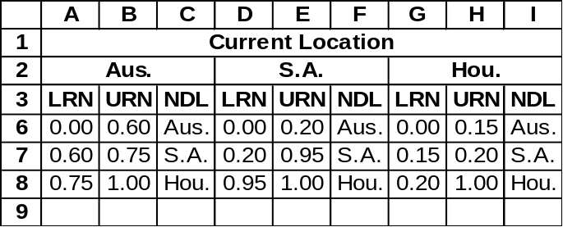d) Partial Spreadsheet with Variable Look-up Table

LRN = Lower Random Number
URN = Upper Random Number
NDL = Next-Day Location

Partial Spreadsheet with Simulation Table

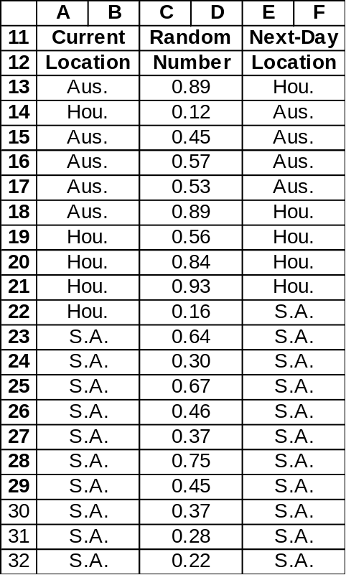
IF(A13=$A$2,VLOOKUP(C13,$A$6:$C$8,3),
IF(A13=$D$2,VLOOKUP(C13,$D$6:$F$8,3),
VLOOKUP(C13,$G$6:$I$8,3)))

PROBLEM 6

Consider the following house renovation project.

Expected Completion
Job and Description Time (in days)
A - Remove old roof shingles 2
B - Plaster walls and ceilings 4
C - Lay new roof shingles 3
D - Paint exterior 5
E - Paint walls and ceilings 4
F - Hang new gutters 2
G - Install exterior lights 2
H - Lay wall-to-wall carpet 2

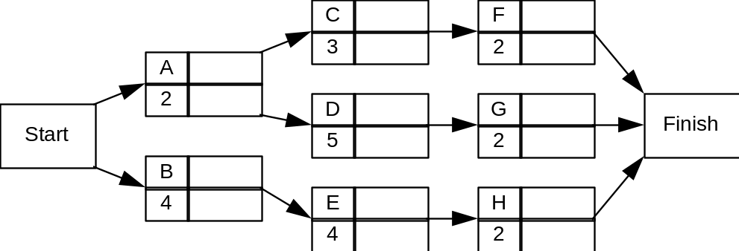

For each job the probabilities of being completed 1 day earlier than expected, on time, 1 day later than expected, and 2 days later than expected are .2, .5, .2, and .1, respectively.

a) Determine the critical path(s) and the project's expected completion time.

b) Do a five trial simulation using the last digit of column 4 of Appendix E for the random numbers to determine the average completion time of the project. Compare this result with your answer to part (a).

SOLUTION 6

a) A path in this context is a set of successive jobs that lead from the project network's starting node (node 1) to the finish node (node 7). There are three different paths in the network. They are A-C-F, A-D-G, and B-E-H. The critical (longest) path consists of jobs B-E-H. The project's expected completion time is the sum of the expected completion times of the jobs on the critical path. Thus, the expected project completion time is 4 + 4 + 2 = 10 days.

Note: Project Scheduling is covered in Chapter 12. The critical path method (CPM) and other techniques are demonstrated.

b) The random number mappings are as follows. Note only single digit random numbers need be generated.
Random
Job Completion Time Probability Numbers
Expected time minus 1 day .2 0,1
Expected time .5 2,3,4,5,6
Expected time plus 1 day .2 7,8
Expected time plus 2 days .1 9

The table on the following page describes the simulation. Note that due to the randomness of job times, a path other than B-E-H was critical in four out of the five trials.

Job's Time Job's Critical Path and
Job RN Exp. Time Adjustment Act. Time Proj. Compl. Time
A 2 2 0 2
B 5 4 0 4
C 1 3 -1 2
D 2 5 0 5
E 0 4 -1 3
F 7 2 +1 3
G 8 2 +1 3
H 1 2 -1 1 A-D-G = 10
A 7 2 +1 3
B 5 4 0 4
C 8 3 +1 4
D 5 5 0 5
E 5 4 0 4
F 1 2 -1 1
G 5 2 0 2
H 0 2 -1 1 A-D-G = 10
A 8 2 +1 3
B 8 4 +1 5
C 2 3 0 3
D 5 5 0 5
E 6 4 0 4
F 7 2 +1 3
G 4 2 0 2
H 4 2 0 2 B-E-H = 11
A 7 2 +1 3
B 2 4 0 4
C 3 3 0 3
D 6 5 0 5
E 7 4 +1 5
F 6 2 0 2
G 3 2 0 2
H 4 2 0 2 A-D-G = 12
A 8 2 +1 3
B 5 4 0 4
C 1 3 -1 2
D 2 5 0 5
E 2 4 0 4
F 5 2 0 2
G 9 2 +2 4
H 6 2 0 2 A-D-G = 12

Average project completion time is (10+10+11+12+12)/5 = 11 days.

ANSWERED PROBLEMS

PROBLEM 7

Susan Winslow has two alternative routes to travel from her home in Olport to her office in Lewisburg. She can travel on Freeway 5 to Freeway 57 or on Freeway 55 to Freeway 91. The time distributions are as follows:

Freeway 5 Freeway 57 Freeway 55 Freeway 91

Relative Relative Relative Relative
Time Frequency Time Frequency Time Frequency Time Frequency
5 .30 4 .10 6 .20 3 .30
6 .20 5 .20 7 .20 4 .35
7 .40 6 .35 8 .40 5 .20
8 .10 7 .20 9 .20 6 .15
8 .15

Do a five-day simulation of each of the two combinations of routes using columns 1, 2, 3, and 4 of Appendix E for the random numbers. Based on this simulation, which routes should Susan take if her objective is to minimize her total travel time?

PROBLEM 8

The Rumson Post Office serves a small rural town. In any one minute interval during a Saturday morning either 0, 1, 2, or 3 customers arrive with the following probabilities: P(0) = .40; P(1) = .30; P(2) = .20; P(3) = .10.
The only clerk working on Saturday at the post office is Mrs. Smith. Her service time per customer is also a random variable with the following distribution of 1, 2, or 3 minutes per service: P(1) = .80; P(2) = .15; P(3) = .05.
If the system starts empty, simulate the waiting line over a 10 minute interval. Use Appendix E, column 1 to generate the number of arrivals and column 2 to generate service times. What is the average number of customers waiting in line for service?

PROBLEM 9

Consider the following PERT problem.
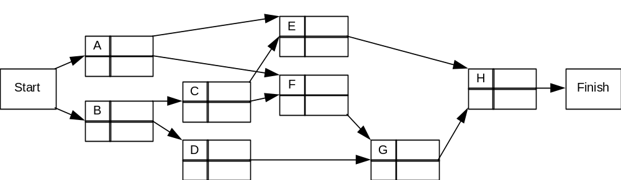
The expected completion time for each job is given below:

Expected Completion
Job Time in Weeks
A 7
B 4
C 3
D 6
E 5
F 3
G 3
H 4

a) Determine the critical path(s) and expected completion time of this project.

b) Suppose that each job has a 25% chance of being completed in a week less than its expected completion time and a 25% chance of being completed in a week more than its expected completion time. Do a five-trial simulation using the last two digits of column 6 of Appendix E for the random numbers to determine the average completion time of this project. Compare this answer to part (a).

PROBLEM 10

Demand for mopeds at the Easy Rider Bike Shop is either 0, 1, 2, or 3 per day with the following probability distribution:

Demand Probability
0 .15
1 .25
2 .35
3 .25

Each working day a moped remains in inventory costs Easy Rider $2 per moped. It costs Easy Rider $30 to process an order.
The delivery time required to obtain new mopeds from the wholesaler is also random with the following distribution:

Delivery Time
(in Working Days) Probability
1 .20
2 .60
3 .20

Easy Rider has adopted the policy of offering customers an $8 per day discount for each working day they must wait for a moped if Easy Rider is out of stock.

a) Assume Easy Rider is open 200 days per year and delivery time is exactly two working days. Further, assume that although demand varies, it is actually constant at the level of average demand. What would be the optimal order policy?

b) Do a 20-day simulation using the answer you obtained in part (a) assuming a current inventory of 6 mopeds and that delivery time and demand follow the distributions given above. Use the first two digits in column 2 of Appendix E to generate demands and the first two digits of column 3 to generate lead times. What is the average inventory cost per day, where inventory holding costs are assessed on ending inventory?

PROBLEM 11

Miller's Carpets runs a store that carries a certain style of carpet. Over the weeks Miller's has collected data concerning the demand for the number of rolls of this brand of carpet:

Weekly Demand Probability
0 .10
1 .20
2 .20
3 .20
4 .20
5 .10

Miller's policy has been to reorder 8 rolls whenever its inventory reached 4 rolls or less at the end of the week. Current inventory is 5 rolls. Reordering costs are $40 per order and holding costs are $2 per roll per week. Stockout costs are $10 per occurrence and these sales are lost.
Lead time for an order has been observed to be:

Weeks Probability
1 .40
2 .50
3 .10
a) Conduct an 8-week simulation of Miller's situation and determine the total cost for this period. Use column 4 of Appendix E for demand and column 6 for lead times.

b) Miller's has been offered a new policy. The wholesaler will automatically deliver 3 rolls to Miller's at the end of each week for a weekly service charge of $12. This eliminates reorder costs and lead times. Should Miller's accept this new policy or keep its current policy?

PROBLEM 12

Customers at Winkies Donuts can either eat their doughnut purchase on the premises or carry it out. Winkies estimates that 35% of its morning business customers enjoy their doughnuts on the premises.
Customers eating their doughnuts on the premises either buy one or two doughnuts and nearly always order a beverage. Winkies estimates the following profits and probabilities hold for service times of the on-the-premises customers:

Service Times Probability Expected Profit
25 seconds .15 $ .08
50 seconds .60 $ .23
75 seconds .25 $ .34

Carry-out customers typically purchase a couple of doughnuts or a dozen. Winkies estimates the following profits and probabilities hold for the service times of carry-out customers:

Service Times Probability Expected Profit
50 seconds .30 $ .15
100 seconds .70 $ .90

During any 25 second interval, either 0, 1, or 2 customers will arrive at Winkies with the following probability distribution:

Customers Probability
0 .75
1 .16
2 .09

Winkies has only one morning sales clerk on duty.

a) Conduct a 10-minute simulation of sales at Winkies. Using Appendix E, use column 1 for number of arrivals in 25 seconds, column 2 for the eat-in/carry-out decision, column 3 for on-the-premises and carry-out service times.

b) What is the expected profit during this period?

c) What percentage of the time is the server busy?

d) What is the average number of customers at Winkies?
PROBLEM 13

Honest Archie's Appliance Company has decided to cease selling microwave ovens. Archie has slashed prices on the three models he has in stock -- Amana, Litton, and Tappan. He currently has 3 Amanas, 2 Littons, and 4 Tappans left in stock.
Because of his low prices, Archie expects to have from one to four customers come into his store each day inquiring about the ovens. Archie believes the following daily probabilities hold:
Customers Probability
1 .50
2 .30
3 .10
4 .10

For each inquiry, Archie believes the following probabilities hold: P(not interested in any purchase) = .30; P(desires Amana) = .30; P(desires Litton) = .25; P(desires Tappan) = .15.
If a customer desires a particular brand of oven that Archie is sold out of, Archie will try to sell the customer the brand of oven in which his current stock is the largest. (If there is a tie, he chooses the one that had the largest initial stock.) Archie believes there is a 25% chance he will be successful in convincing the person to switch to that brand and a 75% chance of losing the sale.
Do a simulation to determine the number of days it will take Archie to sell out his stock of microwave ovens. Use column 7 of Appendix E for arriving customers, column 8 for oven preference, and column 9 for brand switching.

PROBLEM 14

As the owner of a rent-a-car agency you have determined the following statistics:

Potential Rentals Daily Probability Rental Duration Probability
0 .10 1 day .50
1 .15 2 days .30
2 .20 3 days .15
3 .30 4 days .05
4 .25

The gross profit is $40 per car per day rented. When there is demand for a car when none is available there is a goodwill loss of $80 and the rental is lost. Each day a car is unused costs you $5 per car. Your firm initially has 4 cars.

a) Conduct a 10-day simulation of this business using column 1 of Appendix E for demand and column 2 for rental length.

b) If your firm can obtain another car for $200 for 10 days should you take the extra car?

PROBLEM 15

Scooper Dooper is a small ice cream parlor located next to the Lemonville exit of the Metropolitan Subway Line. Arriving customers to Scooper Dooper purchase either ice cream cones, malts, or sundaes. The following table gives the approximate service time required, expected profit, and the probability of each type of purchase:

Service Time Expected
Purchase Probability Required Profit
Ice Cream Cone .75 30 seconds $.12
Malt .15 60 seconds $.22
Sundae .10 90 seconds $.30

The store is small, holding a maximum of four customers. Customers who find the store full go elsewhere for their ice cream. Management estimates that during the lunch hour in each 30 second interval there will be either 0, 1, 2, or 3 arrivals with the following probability distribution:

Number of Arrivals Probability
0 .30
1 .40
2 .20
3 .10

Simulate the operation of the Scooper Dooper ice cream parlor for a 15-minute period during the lunch hour. From Appendix E, use column 1 to generate the number of arrivals and column 2 to determine the type of purchase.

a) What is the expected profit earned during this period?

b) What percentage of the customers are lost due to a full store?

c) What is the average size of the waiting line?

PROBLEM 16

Three airlines compete on the route between New York and Los Angeles. Stanton Marketing has performed an analysis of first class business travelers to determine their airline choice. Stanton has modeled this choice as a Markov process and has determined the following transition probabilities.

Next Airline
A B C

A .50 .30 .20

Last Airline B .30 .45 .25

C .10 .35 .55
a) Show the random number assignments that can be used to simulate the first class business traveler's next airline when her last airline is A, B, and C.

- Assume the traveler used airline C last. Simulate which airline the traveler will be using over her next 25 flights. What percentage of her flights are on each of the three airlines? (Use column 3 of Appendix E.)

TRUE/FALSE

___ 17. Given the accuracy of computers, it is not necessary to validate a simulation program.

___ 18. Using the next event simulation approach, the time between system updates is variable.

___ 19. A random number mapping always maps a set of occurrences to numbers between 00 and 99.

___ 20. Computer simulation requires a special purpose simulation language.

___ 21. In comparing different policies using simulation, one should use the same set of random numbers whenever possible.

___ 22. Flowcharts are useful in designing a simulation program.

___ 23. In Monte Carlo simulation, outcomes are determined by choosing a random number and selecting the outcome corresponding to that number.

___ 24. A computer simulator is a device which acts like a computer but is not a computer.

___ 25. One is guaranteed an optimal solution to a problem using simulation.

___ 26. A typical way to avoid start-up problems in simulation is to run the program for a specified time without recording any data corresponding to the simulation.

___ 27. Probabilistic inputs to a Monte Carlo simulation must follow a discrete probability distribution.

___ 28. If there are no probabilistic components in a problem, there is no reason to use computer simulation to solve it.

___ 29. Simulation is a trial-and-error approach to problem solving.

___ 30. If a computer simulator is correctly programmed, there will be no difference between the simulated and real distributions for a probabilistic component.

___ 31. If a computer simulator is properly programmed, different random number sequences will not cause different output results.

